UNITED STATES SECURITIES AND EXCHANGE COMMISSION

WASHINGTON DC 20549

FORM 8-K

CURRENT REPORT

PURSUANT TO SECTION 13 OR 15(d) OF THE

SECURITIES EXCHANGE ACT OF 1934

Date of Report (Date of earliest event reported) March 21, 2025

CONSUMER PORTFOLIO SERVICES, INC.

 |  |  | (Exact Name of Registrant as Specified in Charter)
 | CALIFORNIA |  |  | 1-11416 |  |  | 33-0459135
(State or Other Jurisdiction |  |  | (Commission |  |  | (IRS Employer
of Incorporation) |  |  | File Number) |  |  | Identification No.)
 |  |  | 3800 Howard Hughes Pkwy, Suite 1400, Las Vegas, NV 89169
 |  |  | (Address of Principal Executive Offices) (Zip Code)
 |  |  | Registrant's telephone number, including area code (949) 753-6800
 |  |  | Not Applicable
 |  |  | (Former name or former address, if changed since last report)

Check the appropriate box below if the Form 8-K filing is intended to simultaneously satisfy the filing obligation of the registrant under any of the following provisions (see General Instruction A.2. below):

- Written communications pursuant to Rule 425 under the Securities Act (17 CFR 230.425)

- Soliciting material pursuant to Rule 14a-12 under the Exchange Act (17 CFR 240.14a-12)

- Pre-commencement communications pursuant to Rule 14d-2(b) under the Exchange Act (17 CFR 240.14d-2(b))

- Pre-commencement communications pursuant to Rule 13e-4(c) under the Exchange Act (17 CFR 240.13e-4(c)) Securities registered pursuant to Section 12(b) of the Act:

Title of each class | Trading Symbol(s) | Name of each exchange on which registered
Common Stock, no par value | CPSS | The Nasdaq Stock Market LLC (Global Market)

Indicate by check mark whether the registrant is an emerging growth company as defined in Rule 405 of the Securities Act of 1933 (§230.405 of this chapter) or Rule 12b-2 of the Securities Exchange Act of 1934 (§240.12b-2 of this chapter).
Emerging growth company ☐

If an emerging growth company, indicate by check mark if the registrant has elected not to use the extended transition period for complying with any new or revised financial accounting standards provided pursuant to Section 13(a) of the Exchange Act. ☐

ITEM 7.01. REGULATION FD DISCLOSURE.

We are today making available one presentation consisting of 19 slides. A copy is attached as an exhibit. Although the exhibit is an update of similar presentations made available from time to time as an exhibit to a report on Form 8-K, we are not undertaking to update further any of the information that is contained in the attached presentation. The same presentation furnished as an exhibit to this report will be made available on our website, at this address:

http://ir.consumerportfolio.com/events-and-presentations/presentations

We routinely post important information, including news releases and reports to the U.S. Securities and Exchange Commission, on our website.

The information furnished in this report shall not be deemed “filed” for purposes of Section 18 of the Securities Exchange Act of 1934, as amended.

ITEM 9.01. FINANCIAL STATEMENTS AND EXHIBITS.

Neither financial statements nor pro forma financial information are filed with this report.

(d) Exhibits

One exhibit is attached:

99.1 Company Summary as of December 31, 2024

104 Cover Page Interactive Data File (embedded within the Inline XBRL document).

SIGNATURES

Pursuant to the requirements of the Securities Exchange Act of 1934, as amended, the registrant has duly caused this report to be signed on its behalf by the undersigned, thereunto duly authorized.

 | CONSUMER PORTFOLIO SERVICES, INC.
Dated: March 24, 2025 | By: /s/ Denesh Bharwani
 |  | Denesh Bharwani
 |  | Executive Vice President and Chief Financial Officer
 |  | Signing on behalf of the registrant

2

Exhibit 99.1


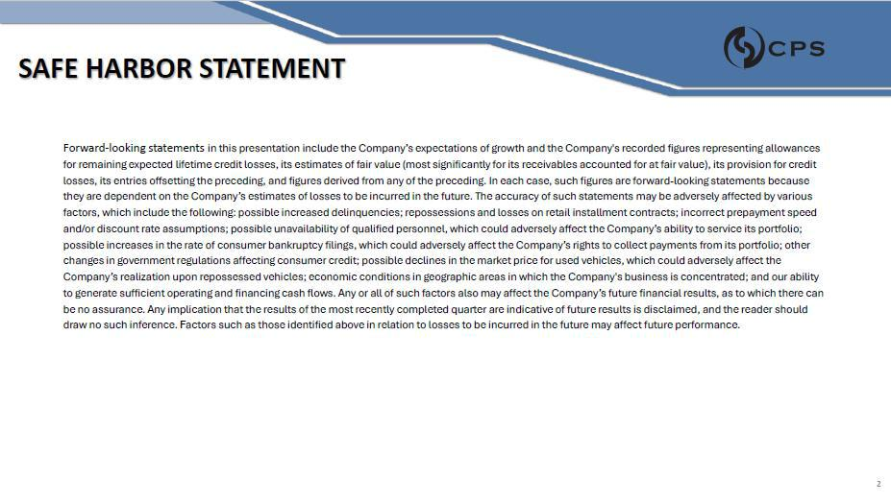

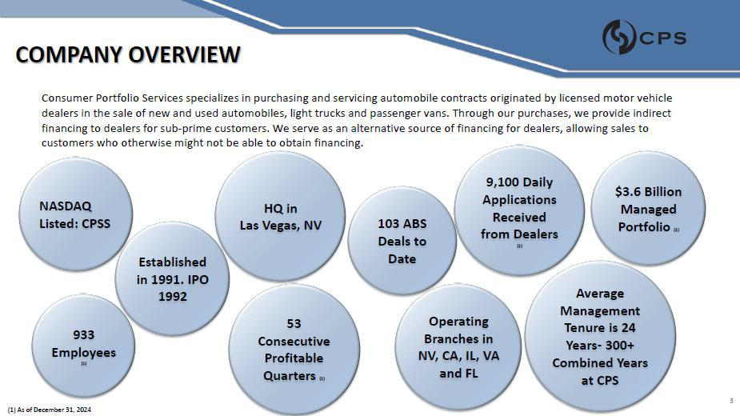

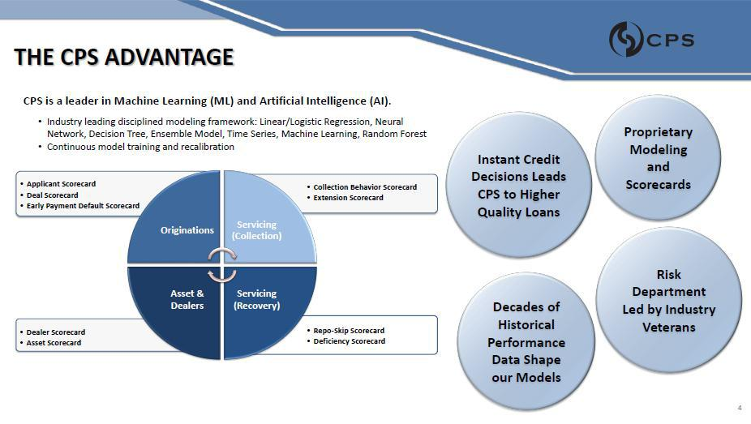

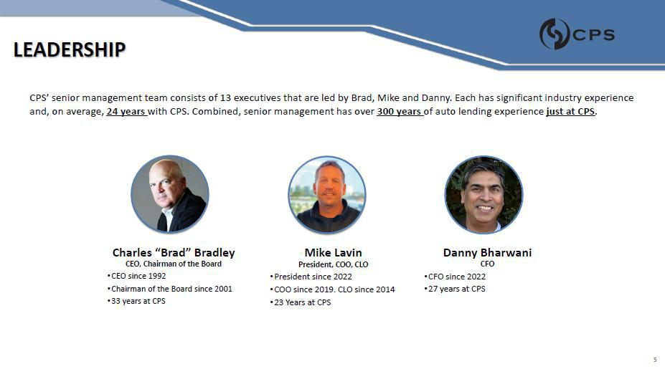

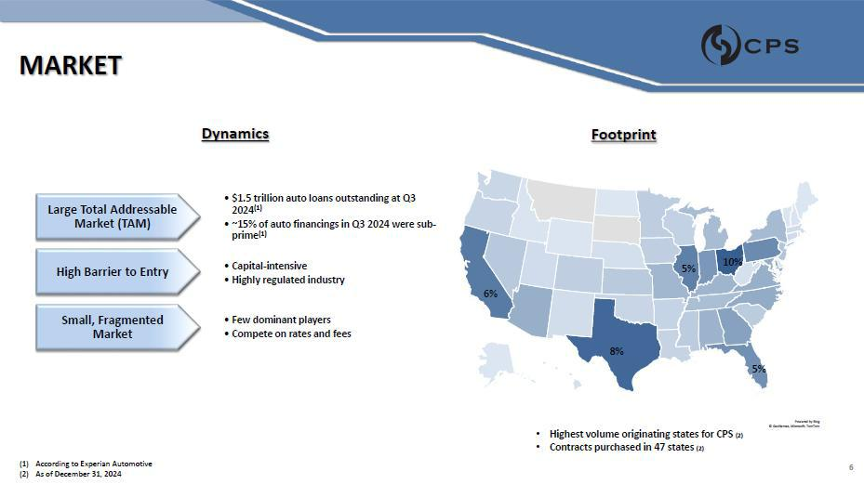

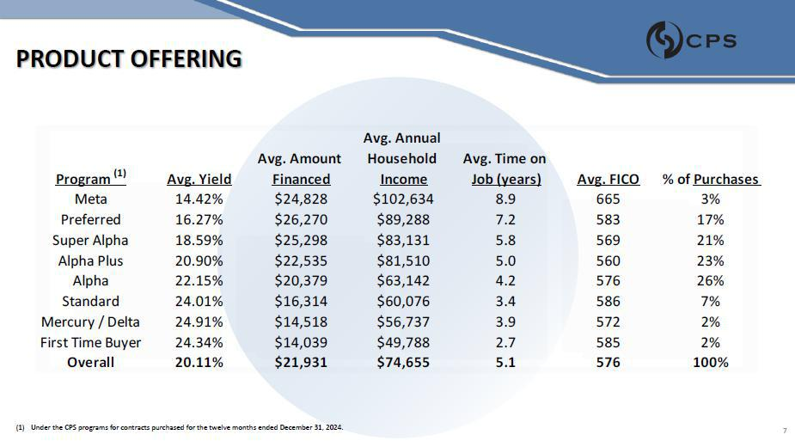

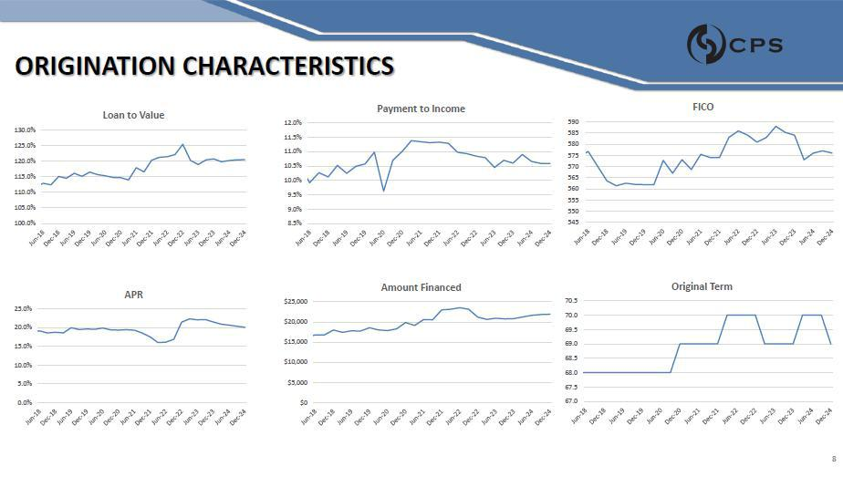

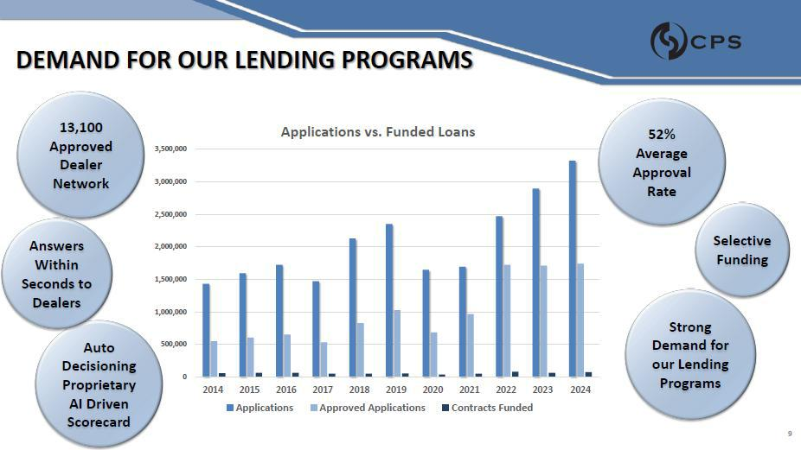

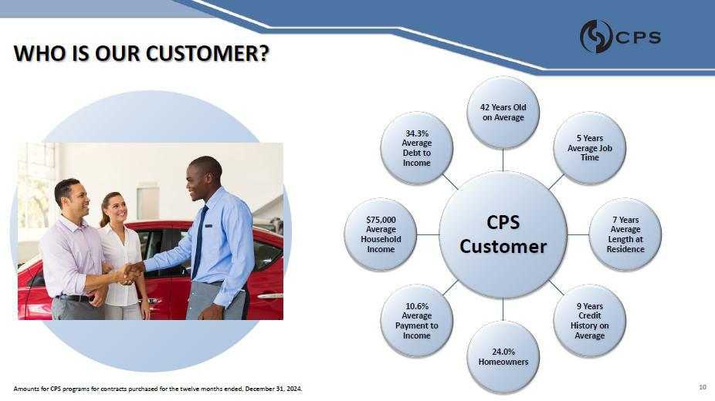

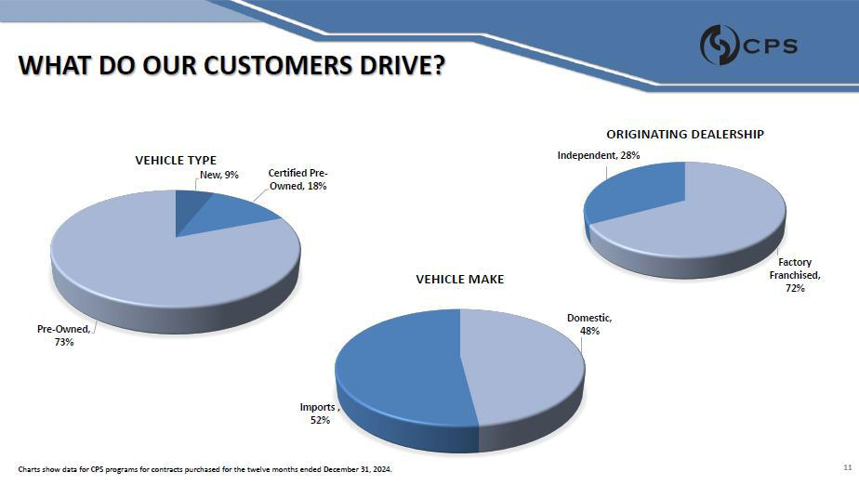

11



